Your Company
TRAINING T200006
HOW TO CREATE A PRINTER ON CUPS SERVER

REVISION HISTORY
VERSION | RELEASE NOTE | ISSUER | DATE
1 | INITIAL RELEASE | Name | Date

Objective
To connect a printer to the CUPS print server on the local network.

Access the CUPS Printer on ADMIN network
The CUPS printer is hosted on the ADMIN network 10.77.7.63 port 631. In thr browser go to 10.77.7.63:631
If you get a Not Found error, it’s because the firewall is blocking your access to the admin network. Request IT to add you to the access list.

Once you have accessed it, select Administration, and enter the credentials for the CUPS printer login. If you do not have the credentials via Keeper, request them from IT.
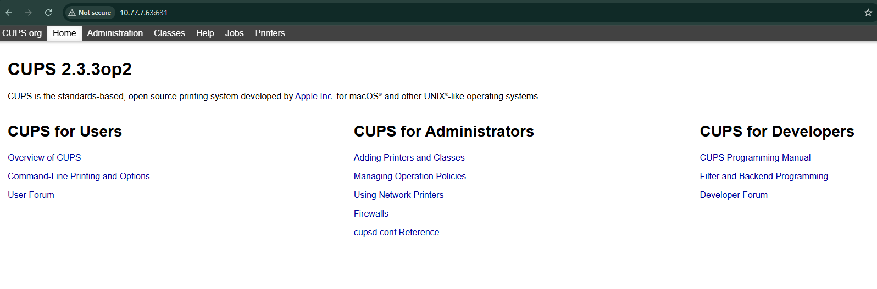
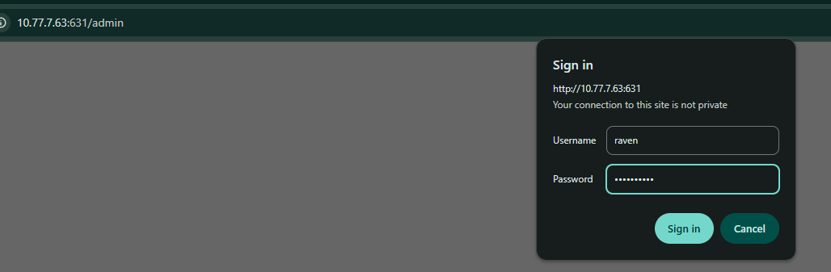

Add a Printer
On the Administration menu, select Add Printer
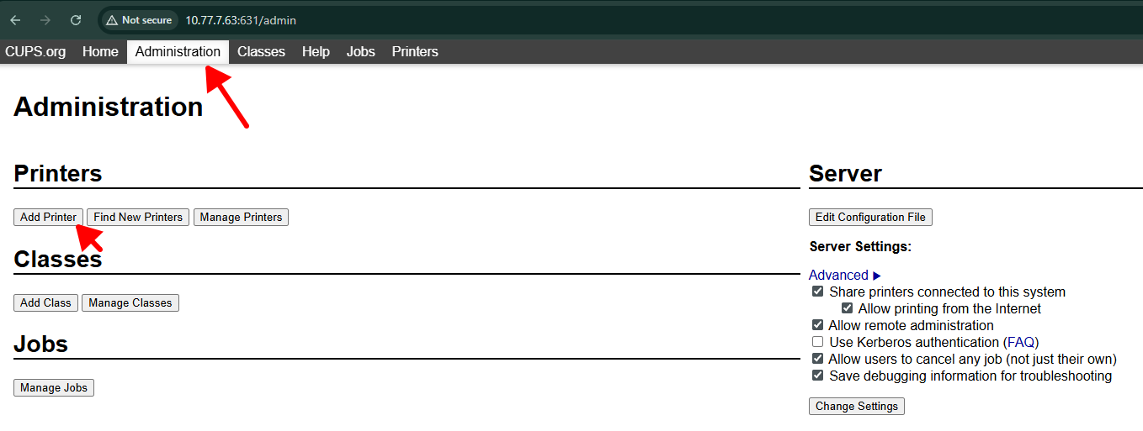
Select the Socket connection type (or alternate protocol if you know which is required for your printer type)
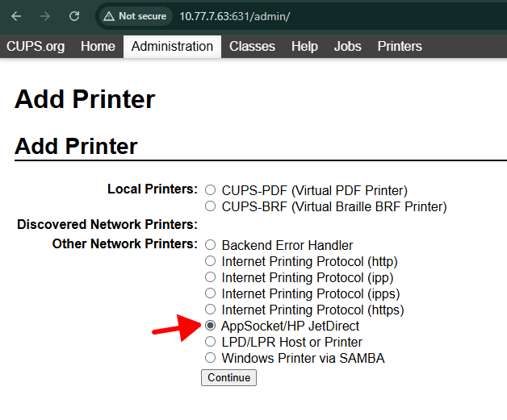

For most printers it will be the Socket type. For Label Printers, it will be the socket type.

Enter the Address to the printer with the correct IP address of your printer, on port 9100 (for most printers)
socket://10.22.0.254:9100
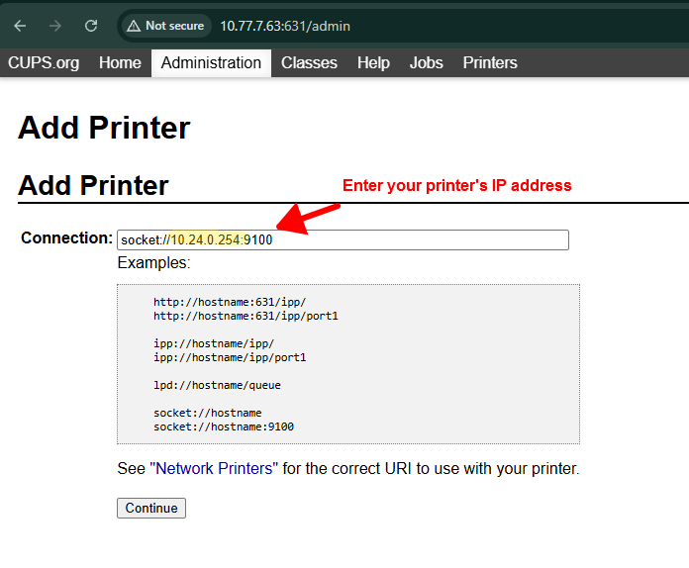

Enter a name for the printer. Select Sharing if you want this available on the network.
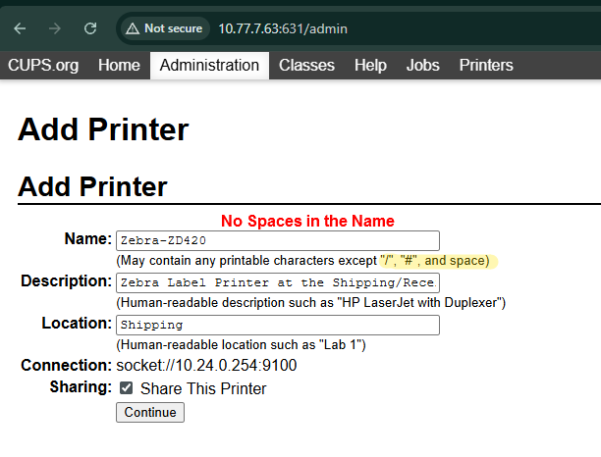

Select the Make:
For Zebra label printers connected to Odoo, we will be using the Raw printer option because Odoo sends ZPL print commands over the wire. Select Continue, then “Add Printer”.
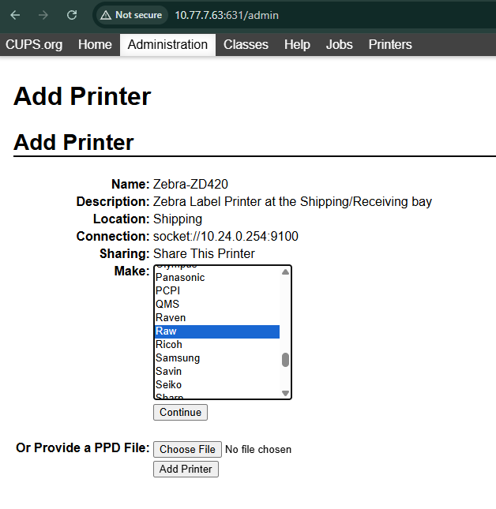

If you Shared the printer, you will be asked again to provide a make/driver for the Sharing side. In our case, we select Zebra then ZPL.
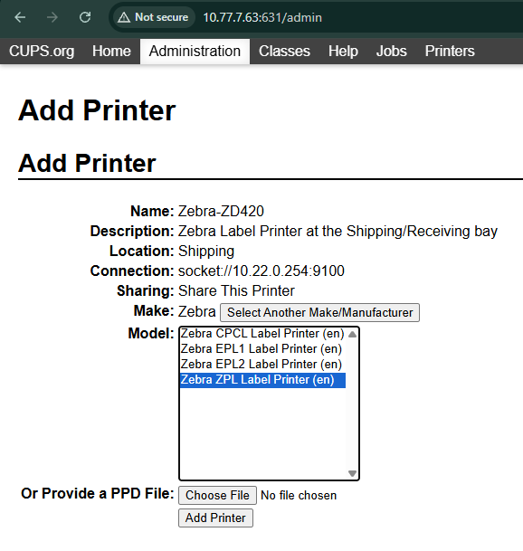

Finally, click Set Default Options:
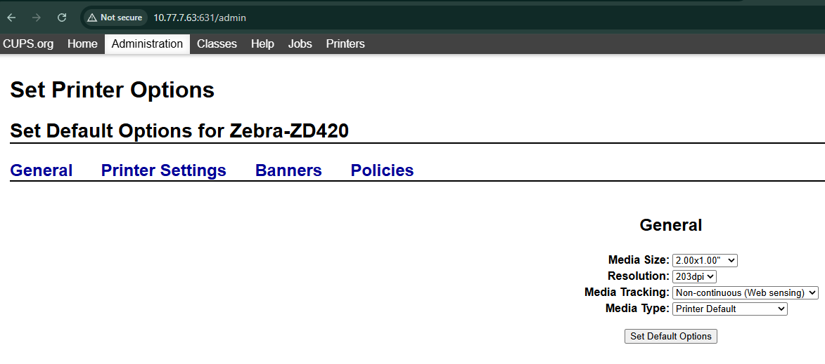
Sometime it just looks like:
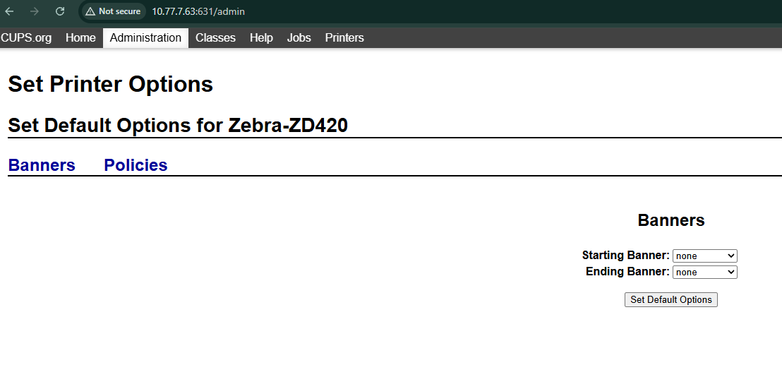
The printer is now ready.

Add to Odoo

Odoo uses a print service called PrintNode, which requires a print agent on the local server to send print jobs to the various connected printers. In the browser, you can access this Odoo print agent on the CUPS server on port 8888:

10.77.7.63:8888
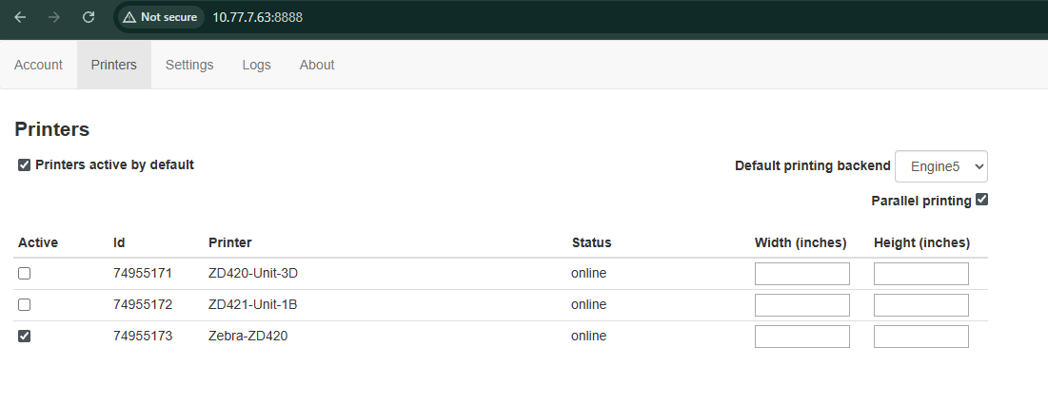
Go to the Printers tab and select the Printers from the CUPS print server that you want to connect to Odoo.
In Odoo, Go to the Direct Prin app and go to Configuration > Settings >Account > Import Printers & Scales, then click “View Printers”
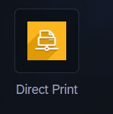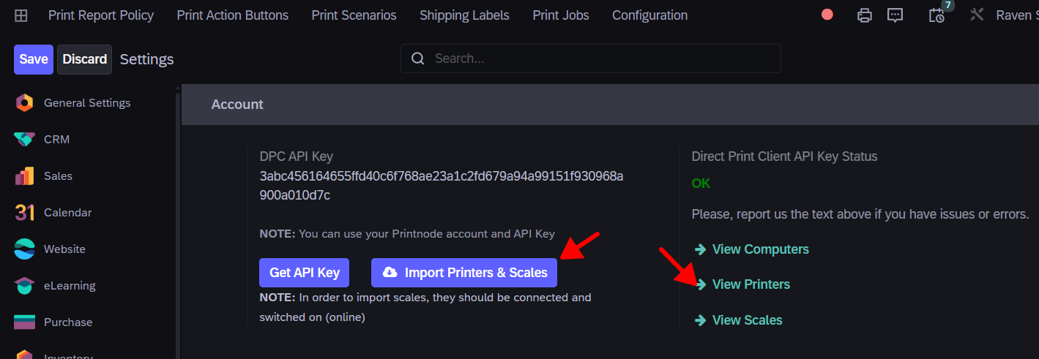

You should see the printer you added on the print server:
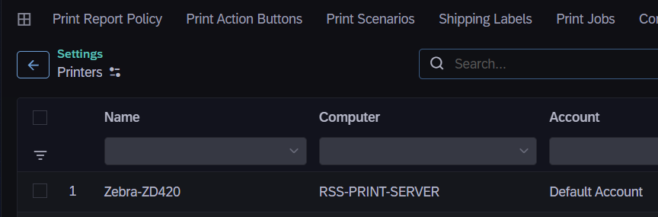
Now go to Configuration > Workstations and Create a new Workstation and add this printer:
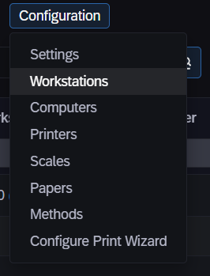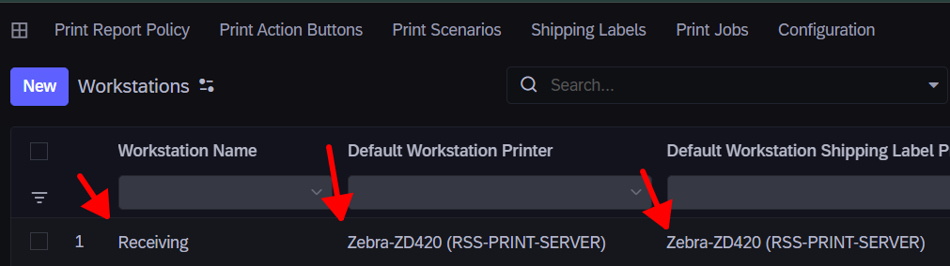

To select this workstation, users must have the Direct Print settings enabled in the User Preferences:
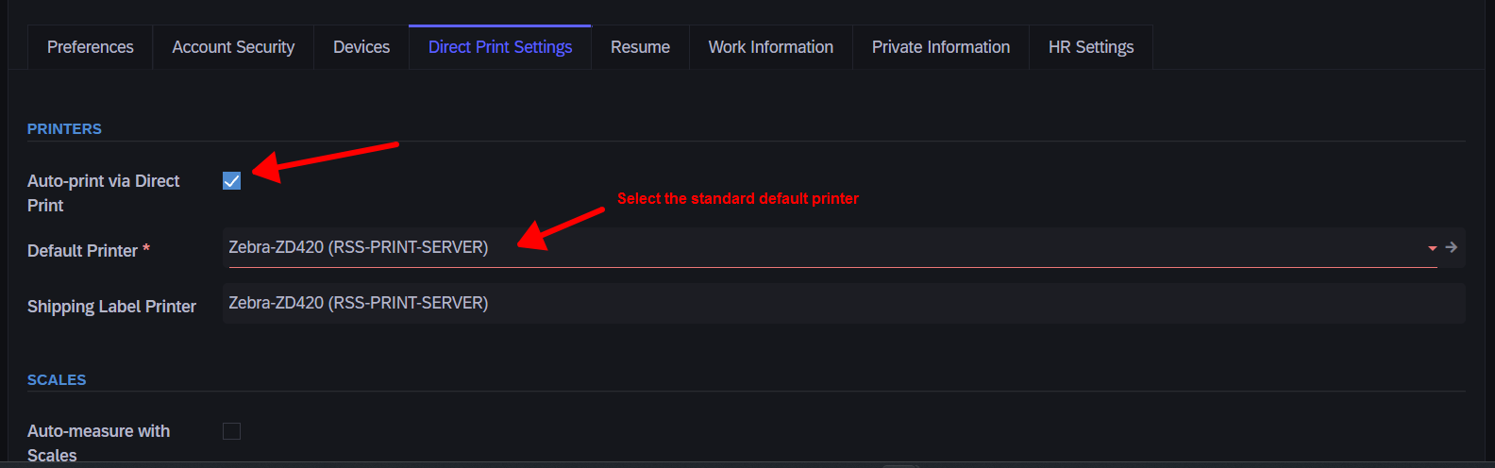
They will be required to set a default printer. Refresh the browser tab (F5). Then select the Print icon in the top right ribbon in any Odoo menu, and select the workstation (may require another refresh). This workstation will override the default printer. If you want to use the default printer, you can unselect a workstation.
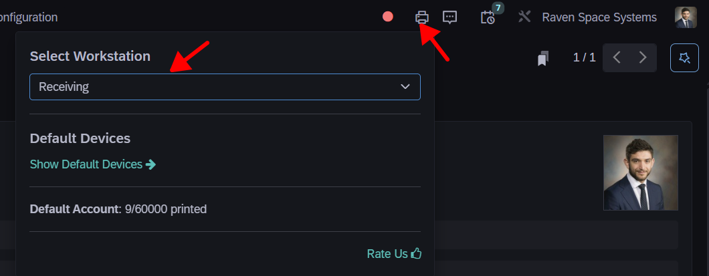
Now if you try to Print a report on a record, for example an Equipment label, it will try to print to this workstation’s printer first:
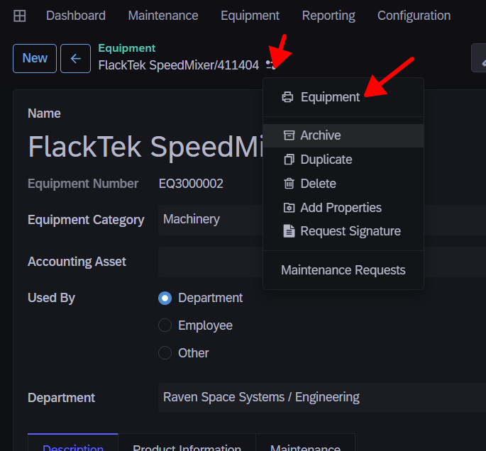

Connect on your Windows PC
If you shared the printer you can also now connect to it on your local PC when you’re on the network. The office network should be on the 10.11.0.0\24 subnet, and the CUPS Print server should be configured with an IP on this subnet. Enter that IP address with the 631 port in the Hostname or IP address section with the /printer/<printer-name> as the suffix
http://10.11.0.252:631/printers/Zebra-ZD-420

